Assignment 3
Two-Dimensional Array ADT
Description
Write a Two-Dimensional Array ADT that is based on the class definition below. Notice the only difference between this implementation and the one written for Assignment 2 is the data type of the m_array data member of the Array2D class.

Class Definitions

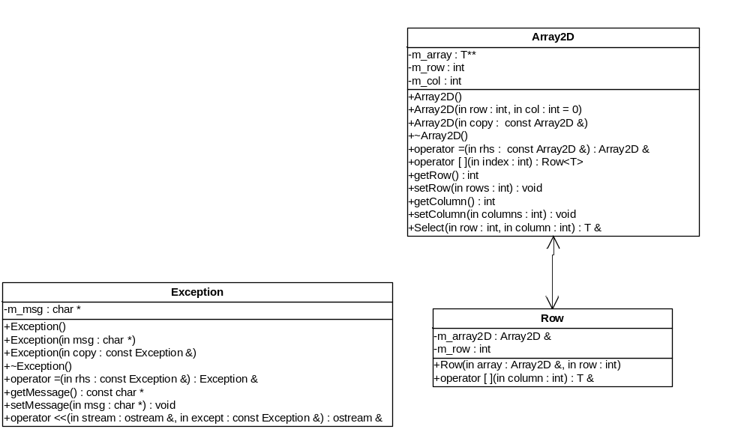

Stipulations
- All of the stipulations from Assignment 2.

